- Navigate to https://jkyog-strapi-staging.up.railway.app/admin/auth/login
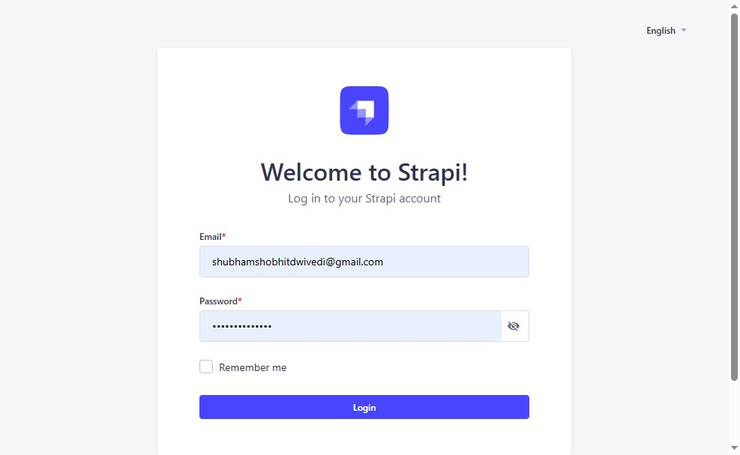
- Click "Login"
- Click "Content Manager"
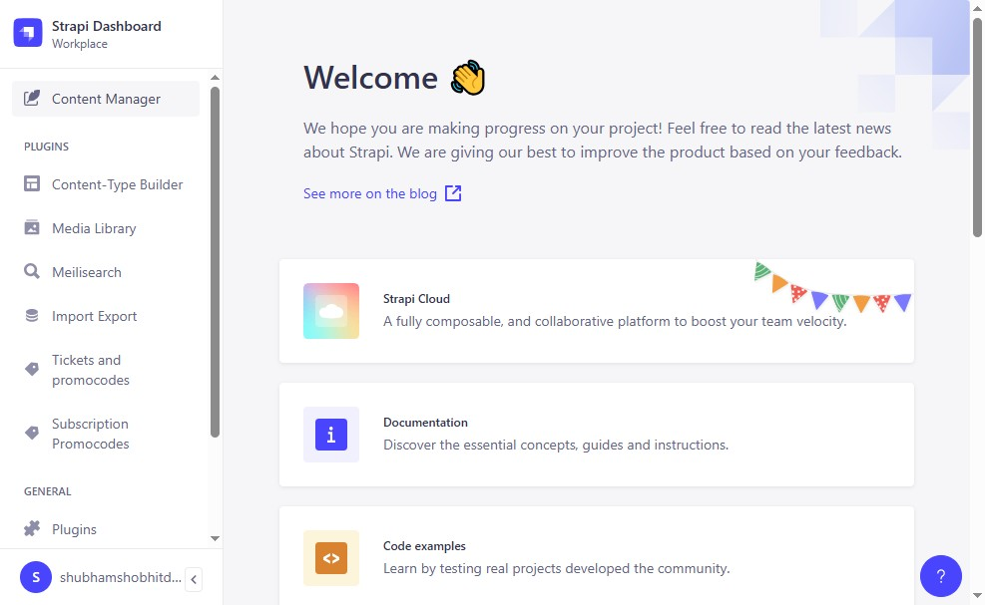
- Click "ContentSearch for a content typeCollection Types39App AnnouncementApp Announcement Content OrderApp ArticlesApp AudiosApp BooksApp ChallengeApp ..."
